**Abstract:**

Since student performance and pass rates in school reflect teaching level of the school and even all education system, it is critical to improve student pass rates and reduce dropout rates. Decision Tree (DT) algorithm and Support Vector Machine(SVM) algorithm in data mining, have been used by researchers to find important student features and predict the student pass rates, however they did not consider the coefficient of initialization, and whether there is a dependency between student features. Therefore, in this study, we propose a new concept: features dependencies, and use the grid search algorithm to optimize DT and SVM, in order to improve the accuracy of the algorithm. Furthermore, we added 10-fold cross-validation to DT and SVM algorithm. The results show the experiment can achieve better results in this work. The purpose of this study is providing assistance to students who have greater difficulties in their studies, and students who are at risk of graduating through data mining techniques.

**Algorithms:**

* Decision Tree (DT) algorithm and
* Support Vector Machine (SVM) algorithm

**Existing System:**

In the education, data mining technology is mainly used for student data analysis, auxiliary teachers and managers to make right decisions. Data mining includes many algorithms, such as DT, association rules, SVM, clustering analysis, and so on. However, compared with other data mining algorithms, the DT is easier to be understood and can be constructed a decision tree for data sets with many attributes, and SVM can solve nonlinear problems and solve high-dimensional problems.

**Proposed System:**

In this paper, we use the classification algorithm in data mining technology, also known as supervised learning DT algorithm and SVM algorithm. Particularly, because the grid search algorithm is a method to optimize the model performance by traversing a given combination of parameters, the algorithm can be used to optimize the DT and SVM algorithms to improve the accuracy of the algorithm. In addition, because different student features have different effects on student pass rates and there is some dependency between the various features, we introduce the features dependences and expert guidance.

**System Architecture:**

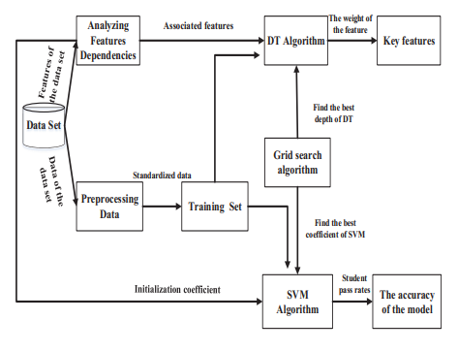

**SYSTEM CONFIGURATION:**

**Hardware requirements:**

Processer                     :           Any Update Processer

Ram                            :           Min 4 GB

Hard Disk                   :           Min 100 GB

**Software requirements:**

Operating System       :         Windows family

Technology                 :           Python 3.6

IDE : PyCharm